

©2019 The Baseball Observer & 360 Peak Performance

coachhelke@yahoo.com



You Have To “Think” Like A Pitcher If You Want To Hit

**Pitch Counts and Hitters Expectations**

Presented by

©2019 The Baseball Observer & 360 Peak Performance coachhelke@yahoo.com



**Pitch Counts and Hitters Expectations**

by Coach Helke

All the research investigated (fangraphs.com, player interviews, college/ pro pitching coach interviews and articles) shows that pitchers want to get ahead in the count early. Ideally, pitchers want to throw two of the first three pitches for strikes. From an interview with David Cone (ex-Yankees pitcher) *“If you get a quick strike early in the count, then you can go to off-speed pitches more.”* With that said…

**GREEN**: Odds favor batter getting a good pitch to hit

**RED**: Odds favor pitcher – batter not getting a good pitch to hit – protect

**BLACK**: On average neutral for both batter and pitcher

**Hunt 0** – “no strike” Hunting Zone **Hunt 1** – One strike Hunting Zone **Hunt 2** – All Zones

**Count HITTER’S PITCH EXPECTATIONS**

*(Not an absolute - it’s a general guideline based on thousands of at-bats in like situations)*

1. **57-60% first pitches are thrown for strikes\*** – **HUNT 0**

**0-1** **Pitcher’s choice** (stay away from 0-2, but you do have a strike to give) – **HUNT 1**

**0-2** **Pitcher’s choice** - Protect the plate (often a waste pitch) – **HUNT 2**

You will rarely see a pitcher throw a fastball over the plate on 0–2. Pitchers who are up

0–2 in the count are taught not to throw the ball over the plate. Instead, they are likely

to throw a fastball up high/ outside low, or a breaking ball/ slider away from the plate

hoping the batter will chase the bad pitch.

**1-0 Fastball** (Tighten your strike zone – **HUNT 0**

* 1. **Pitcher’s best pitch** (don’t panic) – **HUNT 1**

For Greg Maddux, he thought 1-1 was the most important pitch. *"2-1 and 1-2 are*

*different worlds. At 2-1, you have to come to the hitter more. At 1-2, you can use all*

*your tricks to "expand the zone."*

(From the Washington Post – Pay Attention to the count, baseball’s hidden treasure – May 27th, 2010)

* 1. **Pitcher’s choice -Protect the plate** (Expand your strike zone a bit. Be aware the pitcher has pitches to “waste”. – **HUNT 2**

**2-0 Usually fastball** (great hitter’s count – pitcher doesn’t want to go 3-0) – **HUNT 0**

**2-1 Usually Fastball** (great hitter’s count - pitcher doesn’t want to go 3-1) – **HUNT 1**

**2-2 Pitcher’s choice** (Protect the plate. Treat it as 3-2 count) – **HUNT 2**

**IMPORTANT**: Batters seem to lay off decent 2-2 pitches only to swing at worse pitches

on 3-2. Treat 2-2 as 3-2.

**3-0 Fastball** (pitch probably in hitter’s best zone – but you’re usually taking) – **HUNT 0**

**3-1 Fastball** (great hitter’s count) – **HUNT 1**

**3-2 Typically a fastball** (be ready to hit – pitcher doesn’t want to walk) – **HUNT 2**

(But also consider the situation. Ex: If bases loaded (or runner in scoring position) anticipate fastball. If two outs and no one on, anticipate off speed or fastball just out of the strike zone. He has three open bases so a walk doesn’t bother him too much.)

©2019 The Baseball Observer & 360 Peak Performance coachhelke@yahoo.com pg 1

**Quick Important Thoughts to Keep in Mind**

* The bottom line is – don’t let the umpire decide for you – KEEP BATTLING!
* The better you can predict and/ or narrow what type of pitch may be coming, the higher your chance of success.
* If you know ***your*** hitting zones (“Hunting Pitches Zone)”) – your probability of hitting your pitch increases even more. No one is “hot” in the entire strike zone.
* The majority of the time, a pitcher will throw ***at least one pitch*** that is in your perfect Hunting Zone. (excluding an Intentional Walk)
* The goal is work your way to 2-0, 2-1, and 3-1 counts. *“Those are the counts you make your living on.”*
* There are factors you must consider that might affect pitch expectations - score, base runner position(s), inning, hit and run, bunt, etc.

For the most part, there are two predominate types of pitchers and one less predominate.

* Fastball/ Curveball pitchers
* Fastball/ Change Up pitchers
* Fastball/ Slider pitchers (fewer)

They might have a fourth pitch but used infrequently (10-15% of the time – that’s only 10-15 pitches in 100). By knowing what the pitcher throws the majority of the time will also give you an advantage of predicting the next pitch. Again, most pitchers have two pitch types they can throw with control.

If a pitcher does have a fourth pitch, the odds strongly favor they will not go to it when they need a strike because their fourth pitch isn’t their best pitch. But be aware, if they have a third pitch, occasionally they will throw it in a “must need a strike” situation.

Also, the percentages indicate that hitters will get an off-speed pitch 80% of the time on the first pitch with a runner in scoring position and they find themselves with runners in scoring position approximately 25% of the time.

___________________________________________________________________________

**Quick Important Thoughts to Keep in Mind**

As the count changes, so does a batter’s ability to “sit on” a favorite pitch or ignore any ball not in their “Hunting Zone(s).”

Remember – batters seem to lay off 2-2 decent pitches only to swing at worse pitches on 3-2. Treat 2-2 as 3-2.

You want to see all of the pitches the pitcher has to offer. Unless he has a really good fastball, he’s probably not going to throw it every time. So, he’ll have to throw one of his other pitches, and maybe that pitch isn’t as good.

*“Psychologically, what the guy in front of you has done, more often than not, affects how aggressive you are or how much you take pitches. Why? Because batters also learn from their teammates. If one hitter makes an out while swinging at the first pitch, the next batter is much less likely to even consider swinging at the first pitch – even if a good pitch to hit.”*

(source: Grantland – *Debunking MLB First Pitch Strike Myth*)

©2019 The Baseball Observer & 360 Peak Performance coachhelke@yahoo.com pg 2

Skip Bertman, Louisiana State University’s former Hall of Fame head coach, often reminded his hitters to *“Sit on the same pitch that had just retired the previous hitter.”*

(source: Collegiate Baseball Newspaper- Hitter Discipline Can Beat Elite Pitchers)

With runners on base… *The fact that with runners on base a much higher percentage of batters are called out on the 1-2, 2-2 and 3-2 pitches than with bases empty may indicate a psychological bias on the part of umpires to give the pitcher the benefit of close ones with men on base.*

(source: research.sabr.org - Research Journal Archives - Study of ‘The Count’ Yields Fascinating Data)

Batters must have an attack plan to beat the pitcher and you must be flexibility to change your attack when the opponent or an umpire negates your initial approach. Say the ump has a “large” strike zone - you have to adjust to this. Too many batters during the course of a game do not adjust and strike out on an outside pitch that the ump had been calling a strike all night. They come back and say *“That was outside”*. It might have been but tonight the ump calls it a strike. You have to adjust.

***But you also must keep in mind*** that as the level of competition increases (especially college on up) pitchers will sometimes "pitch backwards". It's called pitching backwards because it is the opposite of what is expected in the given situation. But if you pay attention to the pitcher’s tendencies during the game there will be times you'll want to “look” for a backwards approach.

Every player should pick the brains of the pitchers on your team. Ask them their thoughts when they are on the mount and what they do. Ask your pitching coach his philosophies on pitching to batters. You have to “think” like a pitcher if you’re going to hit.

Learn basic pitch recognition!

*Below are stats on first pitch strikes comparing High School and MLB. We can assume the college numbers

are somewhere between the High School and MLB numbers.

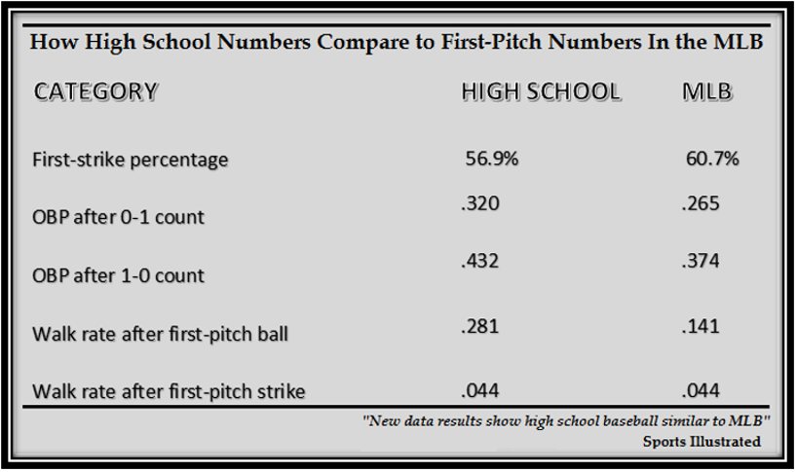

©2019 The Baseball Observer & 360 Peak Performance coachhelke@yahoo.com pg 3